Tenda F3--How to control the speed or access of other device connected with your router

User Scenario 1:

Other device is downloading or watching Video, so that your delay is very high and you could not use your internet to do some real-time work, such as playing online games and video chatting.

User Scenario 2:

You want to forbid some device access to your internet.

Solution:
Step 1: Enter the configuration page of your router.

- Open a browser then type “192.168.0.1” into the Address Bar, press Enter. Then enter the password of this page. Tap “Login”.

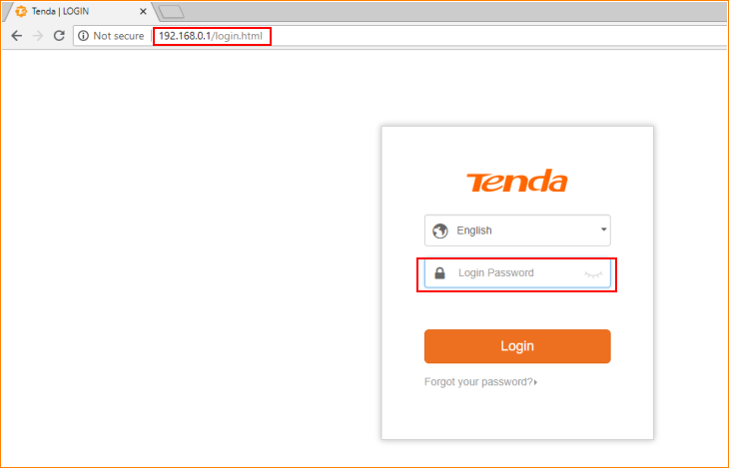

Note: The default password is shown on the bottom of the router. If you have changed it and you also forgot it, see “Forget your password?” below the “Login” button.

- Then the interface will turn into the homepage, tap “Bandwidth control”, and then you can see the interface like the picture below.

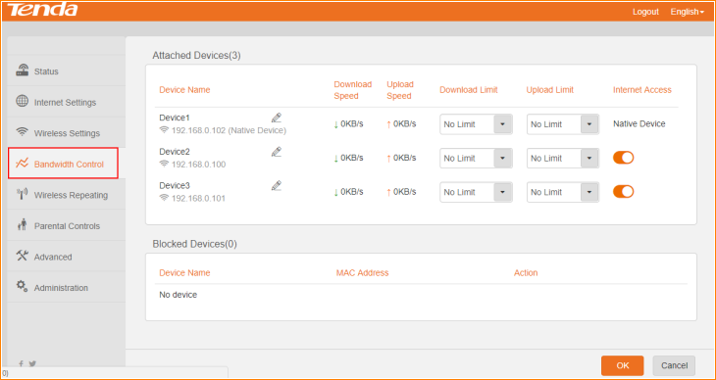

Step2: Control the internet speed of other device. (For user scenario 1)

- For example, if you want to control the maximum speed of the second device. Tap its “Download Limit” and “Upload Limit”, select the Maximum for it, or you can manual set the rate by select “Manual” option, and tap “OK” button to save all settings.

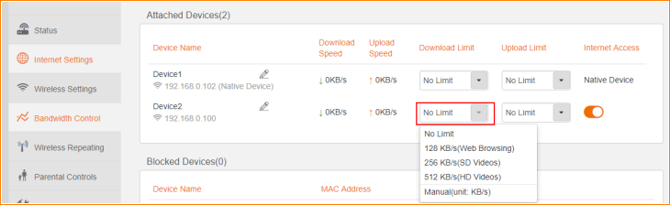

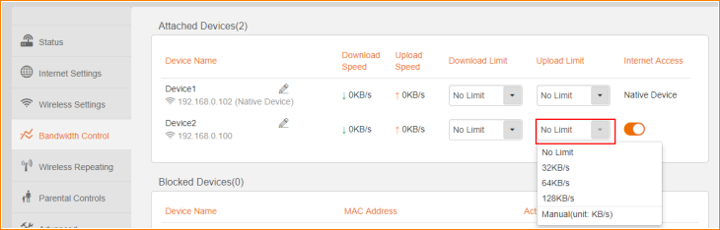

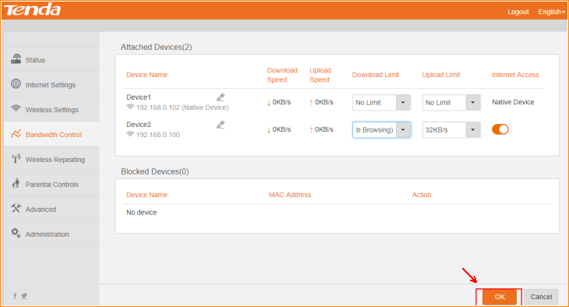

Step3: Control the internet access of other device. (For user scenario 2)

- Tap the “Internet Access” button of the device you want to block, then it will be disabled to access your router. Here set device3 as the example.

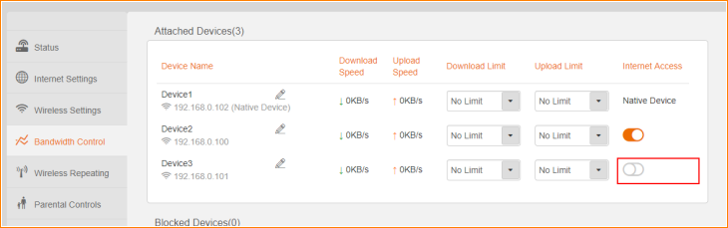

- Tap “OK”. You can see the Device3 is in the list of “Blocked Devices” and it could not connect to internet anymore.

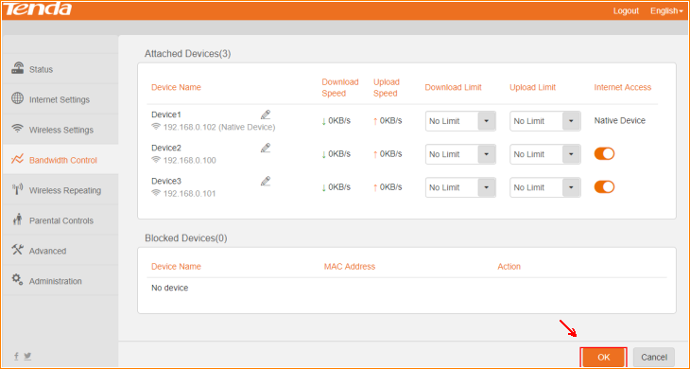

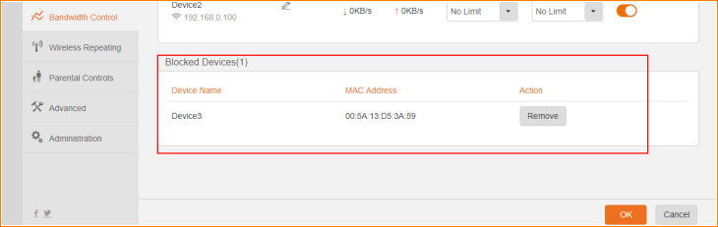

Note: The block rule is based on the MAC address of device.

- If you want to remove the device, tap “Remove” button on the right. Then tap “OK”.

